Problem 3 Let A ∈ M_{n}(R).
- If the sum of each column element of A is 1 prove that there is a nonzero column vector x such that Ax = x.
- Suppose that n =2 and all entries in A are positive. Prove there is a nonzero column vector y and a number  >0 such that Ay= y.
Problem 14 Let G be a finite multiplicative group of 2 × 2 integer matrices.
- Let A ∈ G. What can you prove about
Det A? The (real or complex) eigenvalues of A? the Jordan or Rational Canonical Form of A?
the order of A?
Find all such groups up to isomorphism
Problem 16
- Prove that a linear operator T: C^{n} C^{n} is diagonalizable if for all  ∈ C, Ker(T-  I)^{n} = Ker(T-  I), where I is the n × n identity matrix.
- Show that T is diagonalizable if T commutes with its conjugate transpose T*(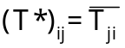. )
Problem 20 Let M_{n} (R)denote the vector space of real n × n matrices. Define a map f: M_{n}(R)  M_{n}(R) by
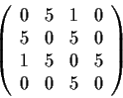
f(X)= X² .Find the derivative of f.

Problem 1 Prove that the matrix has two positive and two negative eigenvalues (counting multiplicities).
Problem 11 Let A and B be n × n matrices over a field Fsuch that A² = Aand B² = B. Suppose that A and B have the same rank. Prove that A and B are similar.
Problem 13 Let F be a finite field with q elements and let Vbe an n-dimensional vector space over F.
- Determine the number of elements in V.
- Let GL_{n}(F)denote the group of all n × n nonsingular matrices over F. Determine the order of GL_{n}(F).
- Let SL_{n}(F) denote the subgroup of GL_{n}(F)consisting of matrices with determinant . Find the order of SL_{n}(F).
Problem 14 Let A, B and C be finite abelian groups such that A × B and A × C are isomorphic. Prove that B and C are isomorphic.
Problem 1 Exhibit a real 3 × 3 matrix having minimal polynomial (t²+1)(t-10), which, as a linear transformation of R³, leaves invariant the line L through (0,0,0)and (1,1,1 )and the plane through (0,0,0) perpendicular to L.
Problem 2 Which of the following matrix equations have a real matrix solution X? (It is not necessary to exhibit solutions.)
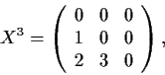
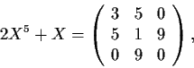
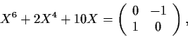
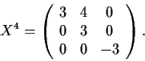

Problem 3 Let T: V V be an invertible linear transformation of a vector space V. Denote by G the group of all maps f_{k,a} : V V where k ∈ Z, a ∈ V and for x ∈ V: f_{k,a}(x)=T^{k}(x)+a (x ∈ V). Prove that the commutator subgroup G’of G is isomorphic to the additive group of the vector space (T-I)V, the image of
T-I. (G’ is generated by all ghg⁻¹h⁻¹, g and h in G.)
Problem 14 Let A and Bbe real 2 × 2 matrices with A² = B² = I, AB+BA = 0. Prove there exists a real nonsingular matrix T with 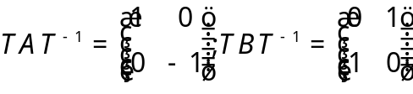.
problem 15 Let E be a finite-dimensional vector space over a field F. Suppose B: E²  F is a bilinear map (not necessarily symmetric). Define subspaces 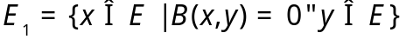 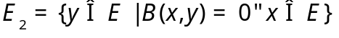. Prove that dimE₁= dim E₂
Problem 5 Let denote the vector space of real n × n skew-symmetric matrices. For a nonsingular matrix A compute the determinant of the linear map T_{A}: S → S : T_{A} (X)= AXA⁻¹
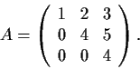
Problem 18 Let A and B be square matrices of rational numbers such that CAC⁻¹ = B for some real matrix C. Prove that such a C can be chosen to have rational entries
Problem 1 Determine the Jordan Canonical Form of the matrix

Problem 7 Let V be the vector space of all real 3 × 3 matrices and let A be the
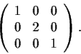
diagonal matrix Calculate the determinant of the linear transformation T on V defined
by T(X) = 1/2 (AX+XA).

Problem 14 Let A be a real n × n matrix such that <AX, X> ≥ 0 for every real n-vector x. Show that
Au = o if and only if A^{t}u=0.

Problem 16 A square matrix A is nilpotent if A^{k} = 0for some positive integer k
- If A and B are nilpotent, is A+B nilpotent? Proof or counterexample.
- Prove: If A is nilpotent, then I-A is invertible.
Problem 19 Let V be a finite-dimensional vector space over the rationals Q and let M be an automorphism of V such that M fixes no nonzero vector in V. Suppose that M^{p} is the identity map on V, where p is a prime number. Show that the dimension of V is divisible by p-1.
Problem 20 Let M_{2× 2} be the four-dimensional vector space of all 2 × 2 real matrices and define
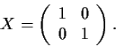
f: M_{2× 2} → M_{2× 2} by f(X)=X².
- Show that f has a local inverse near the point
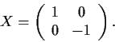
- Show that f does not have a local inverse near the point

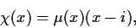
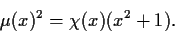
Problem 3 Let A be an n × n complex matrix, and let X and μ be the characteristic and minimal polynomials of A. Suppose that
Determine the Jordan Canonical Form of A.

Problem 6 Let V be a real vector space of dimension n with a positive definite inner product. We say that two bases (a_{i}) and (b_{i}) have the same orientation if the matrix of the change of basis from (a_{i}) to (b_{i})has a positive determinant. Suppose now that (a_{i}) and (b_{i}) are orthonormal bases with the same orientation. Show that (a_{i}+2b_{i}) is again a basis of V with the same orientation as (a_{i}).
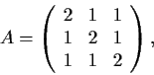
Problem 11 Find the eigenvalues, eigenvectors, and the Jordan Canonical Form of

considered as a matrix with entries in F₃ = Z/Z₃.
Problem 13 Let be an nn complex matrix, all of whose eigenvalues are equal to . Suppose that the set {A^{n} | n=1,2…} is bounded. Show that A is the identity matrix.
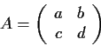
Problem 17 Let A be an n × n Hermitian matrix satisfying the condition Show that A = I..
Problem 4.Let be a real matrix with a,b,c,d > 0 . Show that A has an eigenvector
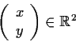
with x, y >0.

Problem 12 Let F_{q} be a finite field with q elements and let V be an n-dimensional vector space over F_{q}.
- Determine the number of elements in V.
- Let GL_{n}(F_{q}) denote the group of all n × n nonsingular matrices A overF_{q}. Determine the order of GL_{n}(F_{q}).
- Let SLn (F_{q}) denote the subgroup of GL_{n}(F_{q}) consisting of matrices with determinant 1. Find the order of SL_{n}(F_{q}).

Problem 13 Let A be a 2 × 2 matrix over C which is not a scalar multiple of the identity matrix I. Show that any 2 × 2 matrix X over C commuting with A has the form X=αI+ βA, where α , β ∈ C.
Problem 14 Suppose V is an n-dimensional vector space over the field F. Let W ⊂ V be a subspace of dimension r < n. Show that
W= ∩ {U| U is an (n-1)- dimenional subspace ß V and W ⊂ U}
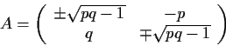
Problem 1
- Show that a real 2 × 2 matrix A satisfies A² = -I if and only if

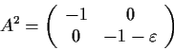
where p and q are real numbers such that pq ≥ 1and both upper or both lower signs should be chosen in the double signs.
- Show that there is no real 2 × 2 matrix A such that with ε >0
Problem 3 Let A be a nonsingular real n × n matrix. Prove that there exists a unique orthogonal matrix Q and a unique positive definite symmetric matrix B such that A=QB
Problem 12 Let A be an n × n real matrix and A^{t} its transpose. Show that A^{t}A and A^{t} have the same range.

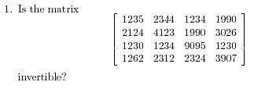
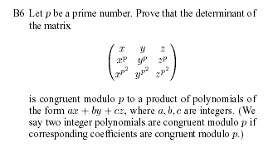
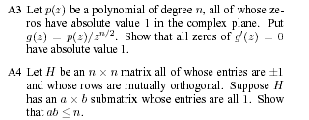
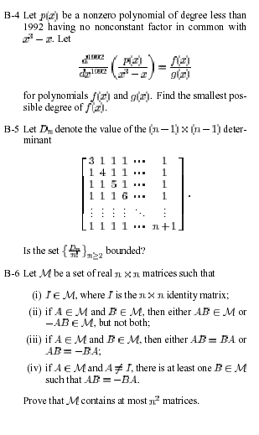

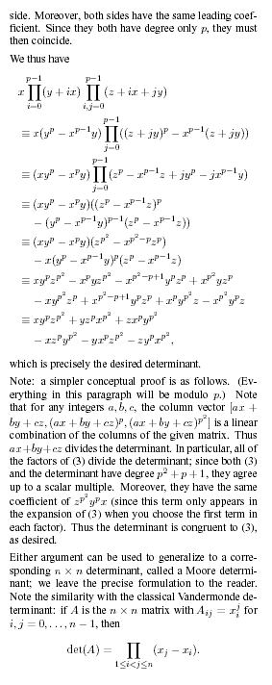

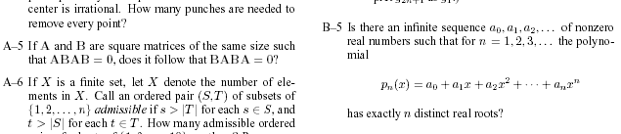

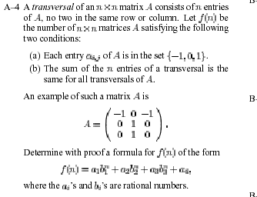
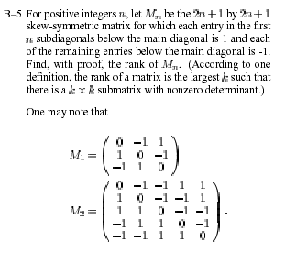

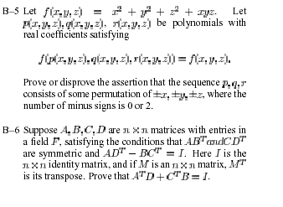

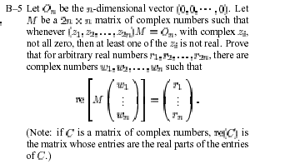

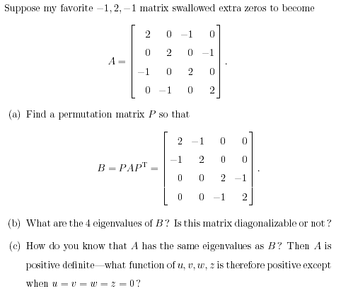

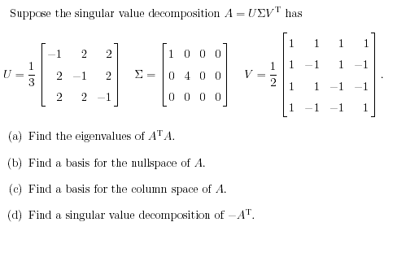

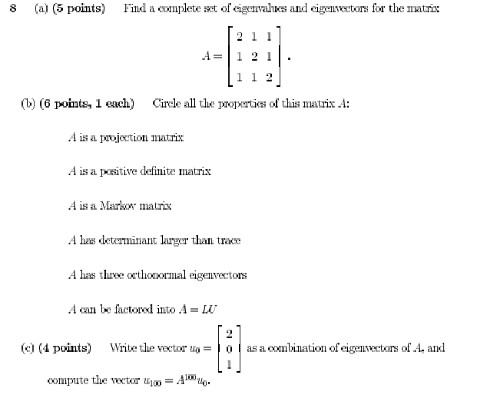

Problem 12 Let V be the vector space of all polynomials of degree ≤ 10, and let D be the differentiation operator on V (i.e., Dp(x)=p’(x))
- Show that trD = 0.
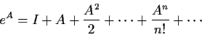
- Find all eigenvectors of D and e^{D}.
Problem 4 Let Abe anr r × r matrix of real numbers. Prove that the infinite sum
of matrices converges (i.e., for each i,j, the sum of (i,j)^{th} entries converges), and hence that
e^{A}is a well-defined matrix.

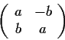
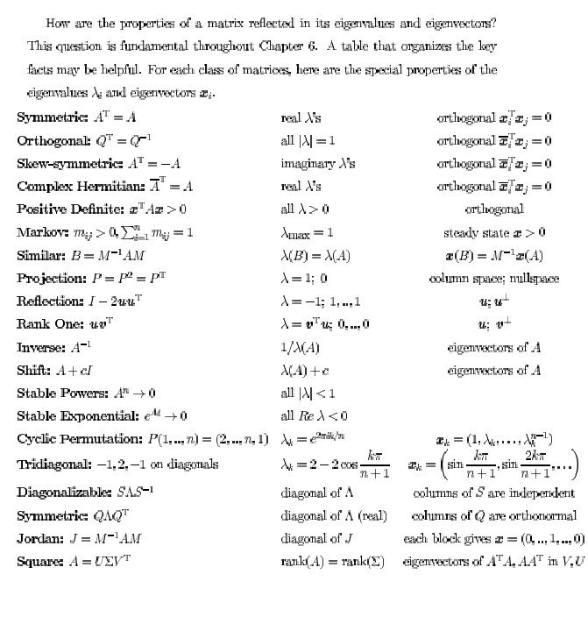
Problem 2 Let R be the set of 2 × 2 matrices of the form
where a, b are elements of a given field F. Show that with the usual matrix operations, R is a commutative ring with identity. For which of the following fields F is R a field: F= Q, C Z₅, Z₇??
Problem 9 Show that every rotation of R³ has an axis; that is, given a 3 × 3 real matrix A such that
A^{t}=A⁻¹ and detA >0 , prove that there is a nonzero vector v such that Av = v.
Problem 15 Let M be a square complex matrix, and let S={XMX-1| X is non- singular}be the set of all matrices similar to M. Show that M is a nonzero multiple of the identity matrix if and only if no matrix in S has a zero anywhere on its diagonal.
Problem 16 Let ||x|| denote the Euclidean length of a vector . Show that for any real m × n matrix M there is a unique non-negative scalar , and (possibly non-unique) unit vectors u ∈ R^{n} and v ∈ R^{m}such that
- ||Mx|| ≤ ||x|| for all x ∈ R^{n},
- Mu= v ; M ^{t} v= u (where M ^{t} is the transpose of M).

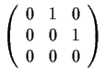
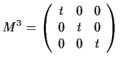
Problem 8 Let M be a 3 × 3 matrix with entries in the polynomial ring R[t] such that . Let N be the matrix with real entries obtained by substituting t = 0 in M.
Prove that N is similar to .

Problem 14 Let A=(a_{ij}) be a n × n complex matrix such that
a_{ij} ≠ 0 if i=j+1but a_{ij} =0 if I ≥ j+2. Prove that A cannot have more than one Jordan block for any eigenvalue.
Problem 7 Suppose that the minimal polynomial of a linear operator T on a seven-dimensional vector space is x². What are the possible values of the dimension of the kernel of T?
Problem 18 Let N be a nilpotent complex matrix. Let be a positive integer. Show that there is a n × n complex matrix A with

Problem 11 Let A, B, … F be real coefficients. Show that the quadratic form
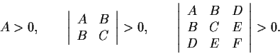
is positive definite if and only if

problem 17 Let A be an n × n complex matrix with tr(A)=0. Show that A is similar to a matrix with all 's along the main diagonal.
Problem 9 Let 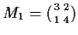, 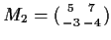, 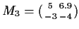. For which (if any) i, 1 ≤ i ≤ 3, is the sequence
(M ^{n}_{i}) bounded away from ∞ ? For which i is the sequence bounded away from O ?
Problem 5 Let Abe the ring of real 2 × 2 matrices of the form 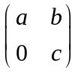 What are the 2-sided ideals in A? Justify your answer
Problem 7 Suppose that A and B are two commuting n × n complex matrices. Show that they have a common eigenvector.
Problem 15 Suppose that P and Q are n × n matrices such that
P²=P, Q² = Q, and 1-(P+Q) is invertible. Show that P and Q have the same rank.
Problem 17 Let GL₂(Z_{m})denote the multiplicative group of invertible 2 × 2 matrices over the ring of integers modulo m. Find the order of GL₂(Zp^{m})for each prime p and positive integer n.
Problem 12 Let M_{2 × 2}be the space of 2 × 2 matrices over R, identified in the usual way with R⁴. Let the function F from M_{2 × 2} into M_{2 × 2}be defined by F(X)= X+X² Prove that the range of Fcontains a neighborhood of the origin.
Problem 15 Suppose that A and B are real matrices such that A^{t} =A, v^{t}Av ≥0 for all v ∈ R^{n} and AB+BA=O.Show that AB=BA=O and give an example where neither A nor B is zero.
Problem 16 Let A be the n × n matrix which has zeros on the main diagonal and ones everywhere else. Find the eigenvalues and eigenspaces of A and compute detA?.
Problem 17 Let G be the group of 2 × 2 matrices with determinant 1 over the four-element field F. Let S be the set of lines through the origin in F² how that G acts faithfully on S. (The action is faithful if the only element of G which fixes every element of S is the identity.) _group action, faithful
Problem 7 Suppose that A and B are endomorphisms of a finite-dimensional vector space V over a field K. Prove or disprove the following statements:
- Every eigenvector of AB is also an eigenvector of BA.
- Every eigenvalue of ABis also an eigenvalue of BA.
Problem 9 Let R be the ring of n × n matrices over a field. Suppose S is a ring and h: R → S is a homomorphism. Show that h is either injective or zero.
Problem 14 Show that Det(e^{M}))=e^{tr(M)}
for any complex n × n matrix M, where e^{M} is defined as in Problem

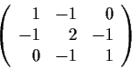
Problem 2 Let A be the 3 × 3 matrix Determine all real numbers a for which the limit 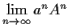exists and is nonzero (as a matrix).
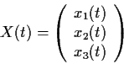
Problem 14 Let W be a real 3 × 3 antisymmetric matrix, i.e.,
W ^{t} =-W. Let the function be a real solution of the vector differential equation dX/dt=WX

Prove that ||X(t)||, the Euclidean norm of X(t), is independent of t.
- Prove that if v is a vector in the null space of W, then X(t)ov is independent of t.
- Prove that the values X(t) all lie on a fixed circle in R³.
Problem 11 Let T: R^{n} → R^{n} be a diagonalizable linear transformation. Prove that there is an orthonormal basis for R^{n} with respect to which T has an upper-triangular matrix
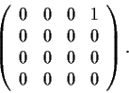
Problem 10 Let A denote the matrix For which positive integers n is there a complex 4 × 4 matrix X such that X^{n} = A ?

Problem 12 Let A be a real symmetric n × n matrix with nonnegative entries. Prove that A has an eigenvector with nonnegative entries.
Problem 2 Let A be a real n × n matrix. Let M denote the maximum of the absolute values of the eigenvalues of A.
- Prove that if A is symmetric, then ||Ax|| ≤M ||x|| for all x in R^{n}.
- Prove that the preceding inequality can fail if A is not symmetric.
Problem 6 Prove or disprove: A square complex matrix, A , is similar to its transpose, A^{t}.
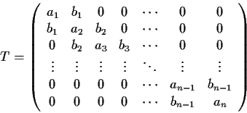
Problem 8 Let T be a real, symmetric, n × n, tridiagonal matrix:

(All entries not on the main diagonal or the diagonals just above and below the main one are zero.) Assume b_{j} ≠ 0 for all j.
Prove:
- rankT ≥ n-1
- T has n distinct eigenvalues.
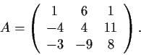
Problem 14 Let x(t) be a nontrivial solution to the system dx/dt=Ax where

Prove that ||x(t)|| is an increasing function of t.
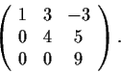
Problem 16 Let A be a linear transformation on an n-dimensional vector space over C with characteristic polynomial (x-1)^{n}. Prove that A is similar to A⁻¹.
Problem 2 Find a square root of the matrix How many square roots does this matrix have?

Problem 14 Let A and B be subspaces of a finite-dimensional vector spaceVsuch that A+B=V. Write n= dimV, a = dim A, and b=dim B. Let S be the set of those endomorphisms f of V for which f(A)⊂ A and f(B) ⊂ B. Prove that S is a subspace of the set of all endomorphisms of V, and express the dimension of S in terms of n, a, and b.
Problem 5 Let A= (a_{ij})^{r}_{i,j=1} be a square matrix with integer entries.
- Prove that if an integer n is an eigenvalue of A, then n is a divisor of detA, the determinant of A.
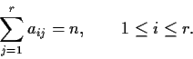
- Suppose that n is an integer and that each row of A has sum n:

Prove that n is a divisor of detA.

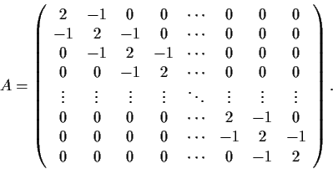
Problem 12 Let n be a positive integer, and let A= (a_{ij})^{n}_{i,j=1} be the n × n matrix with aii=2, a_{ii ±1}=-1 , and a_{ij} = 0 otherwise; that is, Prove that every eigenvalue of A is a positive real number.

Problem 18 For which positive integers n is there a 2 ×2 matrix

with integer entries and order n; that is, A^{n} =I but A^{k} ≠ I for 0< k< n?
Problem 2 Let F be a field, n and m positive integers, and A an n × n matrix with entries in F
such that A^{m} = O. Prove that A^{n}=O.
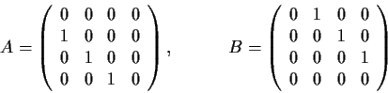
Problem 7 Let Find the general solution of the matrix
differential equation dX/dt=AXB

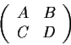
for the unknown 4 × 4 matrix functionX(t).
Problem 10 Let the real 2n × 2n matrix X have the form

where A, B, C, and D are n × n matrices that commute with one another. Prove that X is invertible if and only if AD-BC is invertible
Problem 15 Let B=(b_{ij})²⁰i,j=1be a real 20 × 20 matrix such that
b_{ii}=0 for 1 ≤ I ≤ 20bij ∈ {-1; 1} for 1 ≤ i, j ≤ 20; i ≠ j Prove that B is nonsingular.
Problem 2 Let A be a complex n × n matrix that has finite order; that is, A^{k} = I for some positive integer k. Prove that A is diagonalizable.
Problem 18 Let A and B be two diagonalizablen × n complex matrices such that AB=BA Prove that there is a basis for C^{n} that simultaneously diagonalizes A and B.
Problem 6 Prove or disprove: There is a real n × n matrix A such that A²+2A+5I=O.if and only if n is even.
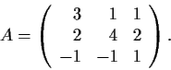
Problem 15 Compute A¹⁰ for the matrix:

Problem 16 Let X be a set and V a real vector space of real valued functions on X of dimension n, 0 < n < ∞ Prove that there are n points x₁,x₂,…, x_{n} in X such that the map
f → (f(x₁), f(x₂), …, f(x_{n})) of V to R^{n} is an isomorphism. (The operations of addition and scalar multiplication in V are assumed to be the natural ones.)
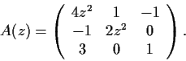
Problem 9 Let A be an m × n matrix with rational entries and b an m-dimensional column vector with rational entries. Prove or disprove: If the equation Ax=b has a solution x in C^{n}, then it has a solution with x in Q^{n}.
Problem 8 Let the 3 × 3 matrix function A be defined on the complex plane by

How many distinct values of are there such that |z|<1 and A(z) is not invertible?
Problem 13 Let S be a nonempty commuting set of n × n complex matrices (n ≥1). Prove that the members of S have a common eigenvector
Problem 6 Let A and B be two n × n self-adjoint (i.e., Hermitian) matrices over C such that all eigenvalues of A lie in [a; a’] and all eigenvalues of B lie in [b; b’]. Show that all eigenvalues of A+B lie in [a+a’; b+b’]
Problem 10 For arbitrary elements a, b and c in a field F, compute the minimal polynomial of the matrix
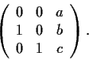
Problem 18 Let A and B be two n × n self-adjoint (i.e., Hermitian) matrices over C and assume A is positive definite. Prove that all eigenvalues of AB are real.
Problem 6 Let V be a finite-dimensional vector space and A and B two linear transformations of V into itself such that A²=B²=Oand AB+BA=I..
- Prove that if N_{A} and N_{B} are the respective null spaces of A and B then N_{A}=AN_{B} and N_{B} = BN_{A} and V= N_{A} N_{B}.
- Prove that the dimension of V is even.
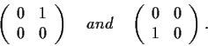
- Prove that if the dimension of V is 2, then V has a basis with respect to which A and B are represented by the matrices

Problem 11 Prove the following statement or supply a counterexample: If A and B are real n × n matrices which are similar over C, then A and B are similar over R
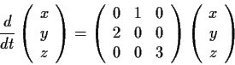
Problem 16 Prove, or supply a counterexample: If A is an invertible n × n complex matrix and some power of A is diagonal, then A can be diagonalized.
Problem 8 Show that the system of differential equations

has a solution which tends to ∞ as t → - ∞ and tends to the origin as t → + ∞
Problem 9 Let A be a real m × n matrix with rational entries and let b be an m-tuple of rational numbers. Assume that the system of equations Ax = b has a solution x in complex n-space C^{n}. Show that the equation has a solution vector with rational components, or give a counterexample.
Problem 11 Let M be an invertible real n × n matrix. Show that there is a decomposition M=UT in which U is an n × n real orthogonal matrix and T is upper-triangular with positive diagonal entries. Is this decomposition unique?
Problem 16 Let V be a real vector space of dimension n, and let S: V × V → R be a nondegenerate bilinear form. Suppose that Wis a linear subspace of V such that the restriction of S to W × W is identically 0. Show that we have dim W≤ n/2.
Problem 5 Let A and B be complex n × n matrices such that AB=BA², and assume A has no eigenvalues of absolute value . Prove that A and B have a common (nonzero) eigenvector
problem 2 LetA= (a_{ij}) be an n × n real matrix satisfying the conditions:
a_{ii} > 0 (i=1,..,n) a_{ij} < 0 (i ≠ j, 1≤ i,j ≤ n);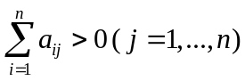 Show that detA > 0
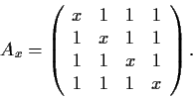
Problem 12 For x ∈ R, let

- Prove that det(A_{x})=(x-1)³(x+3).
- Prove that if x ≠ 1, 3, then A⁻¹_{x}=-(x-1)⁻¹(x+3)⁻¹A_{-x-2}
Problem 14 The set of real 3 × 3 symmetric matrices is a real, finite-dimensional vector space isomorphic to R⁶. Show that the subset of such matrices of signature (2; 1) is an open connected subspace in the usual topology on R⁶
Problem 17 Let b be a real nonzero n × 1 matrix (a column vector). Set M= bb^{t} (an n × n matrix) where b^{t} denotes the transpose of b.
- Prove that there is an orthogonal matrix Q such that QMQ⁻¹=Dis diagonal, and find D.
- Describe geometrically the linear transformation M : R^{n} → R^{n}
Problem 3 Let A and B be n × n complex matrices. Prove that |tr(AB*)|²≤tra(AA*)tr(BB*)
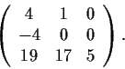
Problem 6 Suppose that f(x) is a polynomial with real coefficients and a is a real number with f(a)≠ 0. Show that there exists a real polynomial g(x) such that if we define p by p(x)= f(x)g(x), we have p(a)=1,p’(a)=0, and p’’(a)=0.
Problem 9 Find the Jordan Canonical Form for the matrix (over R)
Problem 13 Let T: V → W be a linear transformation between finite-dimensional vector spaces. Prove that Dim(kerT)+ dim(rangeT)=dimV
Problem 15 How many nonsingular 2 × 2 matrices are there over the field of p elements
Problem 9 Show that the following three conditions are all equivalent for a real 3 × 3 symmetric matrix A, whose eigenvalues are ₁, ₂, and ₃ :
- trA is not an eigenvalue of A.
- (a+b)(b+c)(a+c)≠ 0.
- The map L: S → S is an isomorphism, where S is the space of 3 × 3 real skew-symmetric matrices and L (W)= AW+WA.
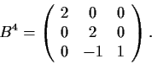
Problem 12 Let M_{3×3} denote the vector space of real 3 × 3 matrices. For any matrix A ∈ M_{3× 3}, define the linear operator L_{A}: M_{3×3} → M_{3×3}; L_{A}(B)=AB. Suppose that the determinant of A is 32 and the minimal polynomial is (t-4)(t-2). What is the trace of L_{A}?
Problem 14 Find a real matrix B such that

Problem 15 Show that a vector space over an infinite field cannot be the union of a finite number of proper subspaces.
Problem 2 Let T be a linear transformation of a vector space V into itself. Suppose x ∈ V is such that
T^{m}x = 0, T^{m-1}x ≠ 0, for some positive integer m . Show that x, Tx, …, T^{m-1}x are linearly independent.
Problem 19 Let P be a 9 × 9 real matrix such that x^{t}Py=-y^{t}Px for all column vectorsx, y in R⁹. Prove that P is singular
Problem 8 Let A and B be n × n complex matrices. Prove or disprove each of the following statements:
- If A and B are diagonalizable, so is A+B.
- If A and B are diagonalizable, so is AB.
- If A² = A, then A is diagonalizable.
- If A is invertible and A² is diagonalizable, then A is diagonalizable.
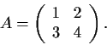
Problem 9 Let Show that every real matrix B such that AB=BA has the form sI+tA, where
s, t ∈ R

Problem 14 Let M_{n × n}denote the vector space of n × n real matrices for n ≥ 2 Let det: M _{n × n} → R be the determinant map.
- Show that det is C∞ .
- Show that the derivative of det at A ∈ M _{n × n} is zero if and only if A has rank ≤ n-2.
Problem 15 Which of the following matrices are similar as matrices over R?
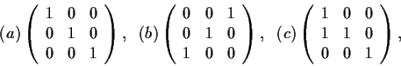
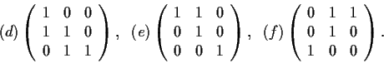

Problem 14 A square matrix A is nilpotent if A^{k} = Ofor some positive integer k.
- If A and B are nilpotent, is A+B nilpotent?
- Prove: If A and B are nilpotent matrices and AB=BA, then A+B is nilpotent.
- Prove: If A is nilpotent then I+A and I-A are invertible.
Problem 9 Determine the Jordan Canonical Form of the matrix
Problem 10 Suppose A is a real n × n matrix.
- Is it true that A must commute with its transpose?
- Suppose the columns of A (considered as vectors) form an orthonormal set; is it true that the rows of A must also form an orthonormal set?
Problem 16 Let A and B denote real n × n symmetric matrices such that AB=BA. Prove that A and B have a common eigenvector in R^{n}.
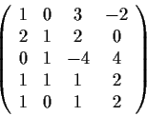
Problem 18 Let M be a matrix with entries in a field F. The row rank of M over F is the maximal number of rows which are linearly independent (as vectors) over F. The column rank is similarly defined using columns instead of rows. Prove row rank = column rank.
- Find a maximal linearly independent set of columns of taking F = R.

2. If F is a subfield of K, and M has entries in F, how is the row rank of M over F related to the row rank of M over K?
problem 8 Let M be a real nonsingular 3 × 3 matrix. Prove there are real matrices S and U such that
M= SU=US, all the eigenvalues of Uequal 1, and S is diagonalizable over C.
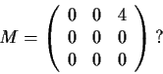
Problem 9 Let M be an n × n complex matrix. Let G_{M} be the set of complex numbers  such that the matrix M is similar to M.
- What is G_{M} if

- Assume M is not nilpotent. Prove G_{M} is finite.
Problem 8 Find a list of real matrices, as long as possible, such that
- the characteristic polynomial of each matrix is (x-1)⁵(x+1)
- the minimal polynomial of each matrix is (x-2)²(x+1)
- no two matrices in the list are similar to each other.
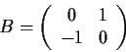
- Find the matrices A(θ) corresponding to :
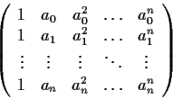
and give a geometric interpretation.
Problem 7 A matrix of the form

where the a_{i} are complex numbers, is called a Vandermonde matrix.
- Prove that the Vandermonde matrix is invertible if a₀,a₁,…, a_{n} are all different.
- If are a₀,a₁,…, a_{n} all different, and b₀,b₁,…, b_{n} are complex numbers, prove that there is a unique polynomial f of degree n with complex coefficients such that f(a_{o})=b_{o}, f(a₁)=b₁,…, f(a_{n})=b_{n}, ,...,
Problem 16 Let A be a complex n × n matrix such that the sequence (A^{n})∞ _{n=1} converges to a matrix B. Prove that B is similar to a diagonal matrix with zeros and ones along the main diagonal
Problem 6 Let G be the collection of 2 × 2 real matrices with nonzero determinant. Define the product of two elements in G as the usual matrix product. _group,>center _matrix,>orthogonal
- Show that G is a group.
- Find the center Z of G; that is, the set of all elements z of Gsuch that az = za for all a ∈ G
- Show that the set O of real orthogonal matrices is a subgroup of G (a matrix is orthogonal if AA^{t}=I, where A^{t} denotes the transpose of A). Show by example that O is not a normal subgroup.
- Find a nontrivial homomorphism from G onto an abelian group.
Problem 5 Let M_{n} be the vector space of real n × matrices, identified in the usual way with the Euclidean space R^{n2}. (Thus, the norm of a matrix X= (x_{jk})^{n} j,k=1 in M_{n} is given by ||X||²=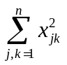.) Define the map f of M_{n} into M_{n} by f(X)=X² . Determine the derivative Df of f.
Problem 6 Let T: V → V be a linear operator on an n dimensional vector space V over a field F. Prove that T has an invariant subspace Wother than {O}and V if and only if the characteristic polynomial of T has a factor f ∈ F[t] with 0 < deg f < n.
Problem 11 Let V be a finite dimensional vector space over a field F, and let A and B be diagonalizable linear operators on V such that AB=BA. Prove that A and B are simultaneously diagonalizable, in other words, that there is a basis for V consisting of eigenvectors of both A and B.
Problem 15 Let A be an n × n complex matrix such that trA^{k} = 0 for k=1,…,n. Prove that A is nilpotent
Problem 1 Are the 4 × 4 matrices
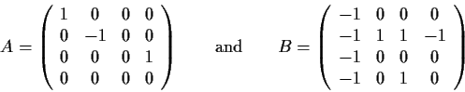
similar? Explain your reasoning.
Problem 6 Let A be an n × n matrix over C whose minimal polynomial μ has degree k.
- Prove that, if the point  of C is not an eigenvalue of A, then there is a polynomial p of degree
k-1such that p(A) = (A-I)⁻¹
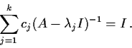
- Let ₁, _{2,…,} _{k} be distinct points of that are not eigenvalues of . Prove that there are complex numbers c₁, c_{2,…,} c_{k} such that
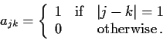
Problem 11 Let A_{n} be the n × n matrix whose entries a_{jk} are given by
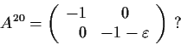
Prove that the eigenvalues of A are symmetric with respect to the origin.
Problem 15 Is there a real 2×2 matrix A such that
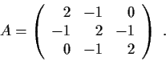
Exhibit such an A or prove there is none.
Problem 16 Let Show that every real matrix B such that AB=BA has the form
B=aI+bA+cA² for some real numbers A, b, and c.

Problem 6 Let A and B be linear transformations on a finite dimensional vector space V
Prove that dim (ker(AB))≤ dim (kerA)+ dim kerB.
Problem 7 A real symmetric n × n matrix A is called positive semi-definite if x^{t}Ax ≥ 0for all x ∈ R^{n}. Prove that A is positive semi-definite if and only if trAB ≥ 0 for every real symmetric positive semi-definite n× n matrix B .
Problem 15 Let A and B be n×n matrices. Show that the eigenvalues of AB are the same as the eigenvalues of BA.
Problem 16 Let B be a 3×3 matrix whose null space is 2-dimensional, and let x()be the characteristic polynomial of B. For each assertion below, provide either a proof or a counterexample.
- ² is a factor of x()
- The trace of B is an eigenvalue of B.
- B is diagonalizable.
Problem 17 Let F be a finite field with q elements. Denote by GL_{n} (F) the group of invertible n×n matrices with entries if F. What is the order of this group?
Problem 1 Let V and W be finite dimensional vector spaces, let X be a subspace of W, and let T: V → W be a linear map. Prove that the dimension of T⁻¹(X) is at least dimV-dimW+dimX.
Problem 16 Let A and B be nonsimilar n × n complex matrices with the same minimal and the same characteristic polynomial. Show that n ≥4 and the minimal polynomial is not equal to the characteristic polynomial.
Problem 5 Prove that any linear transformation T: R³ → R³ has
- a one-dimensional invariant subspace
- a two-dimensional invariant subspace.
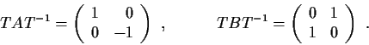
Problem 6 Let A and B be real 2×2 matrices such that A² = B² = I, AB+BA=O
Show that there exists a real 2×2 matrix T such that
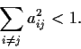
Problem 6 Let A=(a_{ij})^{n}_{i,j=1} be a real n × n matrix such that a_{ii} > 1for all i , and
Prove that A is invertible.
Problem 11 Write down a list of 5×5 complex matrices, as long as possible, with the following properties:
- The characteristic polynomial of each matrix in the list is x⁵;
- The minimal polynomial of each matrix in the list is x³;
- No two matrices in the list are similar.
Problem 15 Let M_{7× 7} denote the vector space of real 7×7 matrices. Let A be a diagonal matrix in M_{7× 7} that has 1 in four diagonal positions and -1 in three diagonal positions. Define the linear transformation T on
M_{7× 7} by T(X) = AX-XA. What is the dimension of the range of T?
Problem 4 Suppose A and B are real n × n matrices and C is a complex n × n matrix such that
CAC⁻¹ = B Find a real n × n matrix D such that DAD⁻¹=B
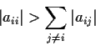
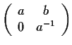
Problem 8 Show that an n × n matrix of complex numbers A satisfying for 1≤ i ≤ n must be invertible.
Problem 15 Let G be the group of all real 2×2 matrices of the form with a > 0. Let N be the subgroup of those matrices in G having a =1. (a) Prove that N is a normal subgroup of G and that G/N is isomorphic to R. (b) Find a proper normal subgroup of G that contains N properly.
Problem 4 Let F be a field. For m and n positive integers, let M_{m ×n} be the vector space of m × nmatrices over F. Fix m and n, and fix matrices A and B in M_{m ×n}. Define the linear transformation T from M_{m ×n} to
M_{m ×n} by : T(X)=AXB Prove that if m ≠ n, then T is not invertible.
Problem 7 Let M_{n ×n} (n ≥ 2) be the space of real n×n matrices, identified in the usual way with the Euclidean space R^{n2}. Let F be the determinant map of M_{n ×n} into R: F(X)=detX. Find all of the critical points of F ; that is, all matrices X such that DF(X)= O. _function,>critical points
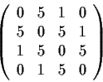
Problem 8 Prove that if A is an n × n matrix over C, and if A^{k} = I for some positive integer k, then A is diagonalizable.
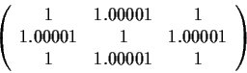
Problem 15 Prove that the matrix has two positive and two negative eigenvalues (taking into account multiplicities).
Problem 2 Prove that the matrix has one positive eigenvalue and one negative eigenvalue.
Problem 8 Let F be a field, V a finite-dimensional vector space over F, and T a linear transformation of V into V whose minimum polynomial, μ is irreducible over F.
- Let v be a nonzero vector in V and let V₁ be the subspace spanned by and its images under the positive powers of T. Prove that dimV₁=degμ
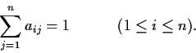
- Prove that degμ divides dimV.
Problem 13 Let A=(a_{ij})^{n}_{i,j=1} be a real n × n matrix with nonnegative entries such that
Prove that no eigenvalue of A has absolute value greater than 1.
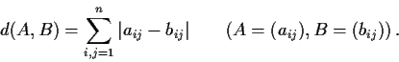
Problem 16 Let M _{n × n} be the space of real n×n matrices. Regard it as a metric space with the distance function Prove that the set of nilpotent matrices in M _{n × n} is a closed set.
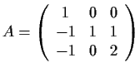
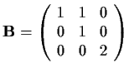
Problem 1 Are the matrices and similar?
Problem 4
- Prove that any real n×n matrix M can be written as M=A+S+cI, where A is antisymmetric, S is symmetric, c is a scalar, I is the identity matrix, and trS = 0.
- Prove that with the above notation,tr(M²)= tr(A²)+tr(S²)+1/n . tr(M)²
Problem 17 Let V be a vector space of finite-dimension n over a field of characteristic 0 . Prove that V is not the union of finitely many subspaces of dimension n-1.
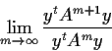
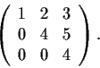
Problem 5 Let A be a real symmetric n × n matrix that is positive definite. Let y ∈ R^{n}, y ≠ 0. Prove that the limit exists and is an eigenvalue of A.

Problem 10 Determine the Jordan Canonical Form of the matrix
Problem 13 Let A be an n × n real matrix, A^{t} its transpose. Show that A^{t}Aand A^{t} have the same range. In other words, given y, show that the equation y=A^{t}Ax has a solution if and only if the equation y=A^{t}z has a solution z.
Problem 13 Let A be a complex n×n matrix, and let C(A) be the commutant of A; that is, the set of complex n × n matrices B such that AB=BA (It is obviously a subspace of M _{n × n}, the vector space of all complex n × n matrices.) Prove that dimC(A)≥n . _matrix,>commutant of a
Problem 3 Let A be a real, upper-triangular, n × n matrix that commutes with its transpose. Prove that A is diagonal.
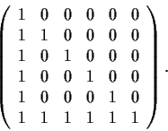
Problem 7 Let A and B be diagonalizable linear transformations of R^{n} into itself such that AB=BA. Let E be an eigenspace of A. Prove that the restriction of B to E is diagonalizable
Problem 4 Find the Jordan Canonical Form of the matrix
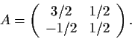
Problem 5 Calculate A¹⁰⁰and A⁻⁷, where
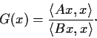
Problem 7 Let A and B be real n× n symmetric matrices with B positive definite. Consider the function defined for x ≠ 0 by Show that G attains its maximum value. Show that any maximum point U for G is an eigenvector for a certain matrix related to A and B and show which matrix.
Problem 8 Let R be the set of 2×2 matrices of the form where a, b are elements of a given field F. Show that with the usual matrix operations, R is a commutative ring with identity. For which of the following fields F is R a field: F=Q,C,Z₅,Z₇?
Problem 12 Given two real n × n matrices A and B, suppose that there is a nonsingular complex matrix C such that CAC⁻¹ = B. Show that there exists a real nonsingular n × n matrix C with this property.
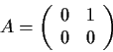
Problem 14 Show that M_{n}(F), the ring of all n × n matrices over the field F, has no proper two sided ideals.
Problem 5 Let M₂ denote the vector space of complex 2×2 matrices. Let
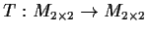
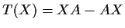
and let the linear transformation be defined by . Find the Jordan Canonical Form for T.
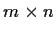
Problem 11 Let A be an matrix with entries in a field F. Define the row rank and the column rank of A and show from first principles that they are equal.
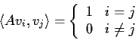
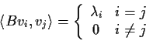
Problem 19 An n ×n real matrix T is positive definite if _matrix,>positive definite T is symmetric and <Tx,x> >0 for all nonzero vectors x ∈ R^{n}, where <u,v> is the standard inner product. Suppose that A and B are two positive definite real matrices. Show that there is a basis{v₁,v₂,…,v_{n}}of R^{n} and real numbers
₁, ₂ ,…, _{n} such that, for 1≤ i,j≤ n: and

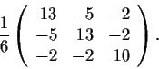
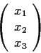
Deduce from Part 1 that there is an invertible real matrix U such that U^{t}AUis the identity matrix and U^{t}BUis diagonal.
Problem 9 Let A be the symmetric matrix We denote by the column vector
x_{i} ∈ R, and by x^{t} its transpose (x₁,x₂,x₃). Let |x| denote the length of the vector x. As x ranges over the set of vectors for which x^{t}Ax=1, show that|x| is bounded, and determine its least upper bound.
Problem 14 Suppose that A and B are endomorphisms of a finite-dimensional vector space V over a field F. Prove or disprove the following statements:
- Every eigenvector of AB is also an eigenvector of BA.
- Every eigenvalue of AB is also an eigenvalue of BA
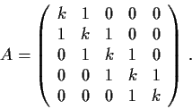
Problem 6 Let k be real, n an integer ≥ 2, and let A= (a_{ij}) be the n × n matrix such that all diagonal entries a_{ii} = k, all entries a_{ii} = ±1 immediately above or below the diagonal equal 1, and all other entries equal 0. For example, if n = 5, Let _{min} band _{max} denote the smallest and largest eigenvalues of A , respectively. Show that _{min} ≤ k-1and _{max} ≥ k+1.

Problem 18 Let P_{n} be the vector space of all real polynomials with degrees at most n. Let D: P_{n} → P_{n} be given by differentiation: D(p)=p’. Let  be a real polynomial. What is the minimal polynomial of the transformation (D)?
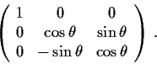
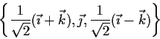
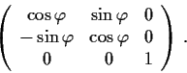
Problem 12 Let θ and ϕ be fixed, 0≤ θ , ϕ ≤ 2 and let R be the linear transformation from R³ to R³whose matrix in the standard basis 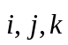 is Let S be the linear transformation of R³ to R³ whose matrix with respect to the basis is
Prove that T= RoS leaves a line invariant
Problem 17 Let M be the n × n matrix over a field F all of whose entries are equal to 1. Find the Jordan Canonical Form of M and discuss the extent to which the Jordan form depends on the characteristic of the field F.
Problem 7 Let R[x₁,x₂,…,x_{n}] be the polynomial ring over the real field Rin the n variables x₁,x₂,…,x_{n} Let the matrix A be the n × n matrix whose i^{th} row is (1, x_{i}, x²_{i}, …, x^{n-1}_{j}),i=1,..,n. Show that detA=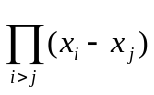
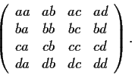
Problem 8 Let a, b, c, and d be real numbers, not all zero. Find the eigenvalues of the following 4×4 matrix and describe the eigenspace decomposition of R⁴:

Problem 20 Let m and n be positive integers,with m<n. Let M_{m × n}be the space of linear transformations of R^{m} into R^{n} (considered as n × m matrices) and let L be the set of transformations in M _{m × n} which have rank m. Show that L is an open subset of M _{m × n}. Show that there is a continuous function
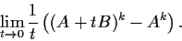
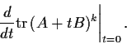
T: L → M _{m × n} such that T(A)A=I_{m} for all A .
Problem 2 Let A and B be n × n real matrices, and k a positive integer. Find
Problem 14 Let V be a finite-dimensional complex vector space and let A and B be linear operators on Vsuch that AB=BA. Prove that if A and B can each be diagonalized, then there is a basis for V which simultaneously diagonalizes A and B.
Problem 16 Let F(t)= (f_{ij}(t)) be an n × n matrix of continuously differentiable functions f_{ij}: R → R, and let
u(t)= tr(F(t)³) Show that u is differentiable and u’(t)= 3 tr(F(t)²F’(t))
Problem 5 Let A be the n × n matrix which has zeros on the main diagonal and ones everywhere else. Find the eigenvalues and eigenspaces of A and compute detA.
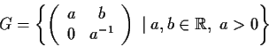
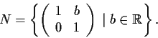
Problem 4 Let M be an n × n matrix of real numbers. Prove or disprove: The dimension of the subspace of R^{n} generated by the rows of M is equal to the dimension of the subspace of R^{n} generated by the columns of M.
Problem 8 Let
- Show that N is a normal subgroup of G and prove that G/N is isomorphic to R.
- Find a normal subgroup N’of G satisfying N ⊂ N’ ⊂ G (where the inclusions are proper), or prove that there is no such subgroup.
Problem 12 Let A and B be complex n × n matrices having the same rank. Suppose that A²=Aand B²=B. Prove that A and B are similar.
Problem 14 Let A be an n × n complex matrix, and let B be the Hermitian transpose of A (i.e.,b_{ij}=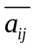). Suppose that A and B commute with each other. Consider the linear transformations α and β on C^{n} defined by A and B. Prove that α and β have the same image and the same kernel.
Problem 2 Let M_{n}(F) denote the ring of n × n matrices over a field F. For n≥1does there exist a ring homomorphism from M_{n+1}(F)onto M_{n}(F)?
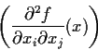
Problem 13 Let f be a real valued function on R^{n} of class C². A point x ∈ R^{n} is a critical point of f if all the partial derivatives of f vanish at x; a critical point is nondegenerate if the n × n matrix :
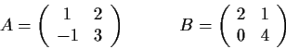
is nonsingular. Let x be a nondegenerate critical point of f. Prove that there is an open neighborhood of x which contains no other critical points (i.e., the nondegenerate critical points are isolated).
Problem 18 Let A and B be two real n × n matrices. Suppose there is a complex invertible n × n matrix U such that A= UBU⁻¹. Show that there is a real invertible n × n matrix V such that A=VBV⁻¹. (In other words, if two real matrices are similar over C, then they are similar over R.)
Problem 9 Let M _{2 × 2} be the vector space of all real 2× 2 matrices. Let
and define a linear transformation L: M_{2× 2} → M_{2× 2} by L(X) = AXB. Compute the trace and the determinant of L.
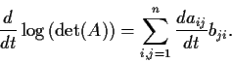
Problem 10 Let A= (a_{ij}) be an n × n matrix whose entries a_{ij} are real valued differentiable functions defined on R. Assume that the determinant detA of A is everywhere positive. Let B=(b_{ij}) be the inverse matrix of A. Prove the formula
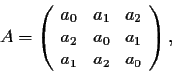
Problem 11 Consider the complex 3× 3 matrix
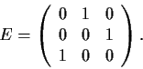
where a_{o},a₁,a₂ ∈ C.
- Show that A= a_{o}I+a₁E+a₂E², where
- Use Part 1 to find the complex eigenvalues of A.
- Generalize Parts 1 and 2 to n × n matrices.
Problem 4 Prove the following three statements about real n × n matrices.
- If A is an orthogonal matrix whose eigenvalues are all different from -1, then I_{n}+A is nonsingular and S= (I_{n}-A)(I_{n}+A)⁻¹ is skew-symmetric.
- If S is a skew-symmetric matrix, then A = (I_{n}-S)(I_{n}+S)⁻¹is an orthogonal matrix with no eigenvalue equal to -1.
- The correspondence A  S from Parts 1 and 2 is one-to-one.
Problem 10 Show that there is an ε >0 such that if A is any real 2× 2 matrix satisfying |a_{ij}|≤ ε for all entries a_{ij} of A, then there is a real 2× 2 matrix X such that X²+X ^{t} = A.. Is X unique?
Problem 14 Exhibit a set of 2×2 real matrices with the following property: a matrix A is similar to exactly one matrix in S provided A is a 2× 2 invertible matrix of integers with all the roots of its characteristic polynomial on the unit circle.
Problem 16 Suppose that A and B are real matrices such that A^{t} = A : v^{t}Av≥0 for all v ∈ R^{n} and AB+BA=O Show that AB=BA=O and give an example where neither A nor B is zero.
Problem 7 Let V be the vector space of sequences (a_{n}) of _Fibonacci numbers complex numbers. The shift operator S: V → V is defined by S((a₁,a₂,a₃,…))=(a₂,a₃,a₄,…)
- Find the eigenvectors of S.
- Show that the subspace W consisting of the sequences (x_{n}) with x_{n+2} = x_{n+1} + x_{n} is a two-dimensional, S -invariant subspace of V and exhibit an explicit basis for W.
- Find an explicit formula for the n^{th} Fibonacci number f_{n}, where f₂ = f₁, f_{n+2}=f_{n+1}+f_{n} for n≥1.
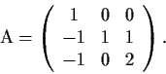
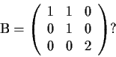
Problem 2 Let Is A similar to
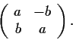
Problem 6 Let M be the ring of real 2× 2 matrices and S ⊂ M the subring of matrices of the form
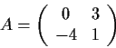
- Exhibit (without proof) an isomorphism between S and C.
- Prove that lies in a subring isomorphic to S.
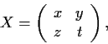
- Prove that there is an x ∈ M such that X⁴+13X=A.
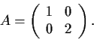
Problem 9 For a real 2×2 matrix let ||X||= x²+y²+z²+t² , and define a metric by d(X,Y)=||X-Y||. Let Σ ={X| detX=0}. Let Find the minimum distance from A to Σ and exhibit an S ∈ Σ that achieves this minimum.
Problem 5 Let A be a real skew-symmetric matrix (a_{ij}=-a_{ij}). Prove that A has even rank.
Problem 6 Let N be a linear operator on an n-dimensional vector space, n >1, such that N^{n} = O, N^{n-1}≠ O. Prove there is no operator X with X²=N.
Problem 3 Let M_{n×n} denote the vector space of n × n real matrices (identified with R^{n2}). Prove that there are neighborhoods U and V in M_{n×n} of the identity matrix such that for every A in U, there is a unique X in V such that X⁴=A.
Problem 8 Let M be the n × n matrix over a field F , all of whose entries are equal to 1.
- Find the characteristic polynomial of M. Is M diagonalizable?
- Find the Jordan Canonical Form of M and discuss the extent to which the Jordan form depends on the characteristic of the field F.
Problem 16 Which pairs of the following matrices are similar?
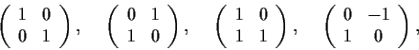
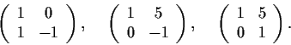

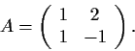
Problem 19 Let Express A⁻¹ as a polynomial in A with real coefficients.
Problem 20 Let M_{n× n} be the vector space of real n × n matrices, identified with R^{n2}. Let X ⊂ M _{n × n} be a compact set. Let S ⊂ C (S ⊂ X?) be the set of all numbers that are eigenvalues of at least one element of X. Prove that S is compact.
105. Define the n x n matrix A by A_{ij} = i j. The elements of A are integers in the range 1 to n². But some numbers appear more than once and some do not appear at all. Let B be the set of numbers which appear at least once and let f(n) = |B|/n². Show that f(n) → 0 as n → ∞. [You may find it helpful to assume the following result. Define g(n) as the number of prime factors of n counting multiplicity,
so g(p₁^{r}₁p₂^{r}₂ ... p_{m}^{r}_{m}) = ∑ r_{i}. Then g(n) ~ ln ln n.]
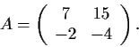
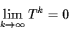
Problem 1 Let Find a real matrix B such that B⁻¹AB is diagonal.
Problem 3 Let T be an n × n complex matrix. Show that
If and only if all the eigenvalues of T have absolute value less than 1.
Problem 4 Let P be a linear operator on a finite-dimensional vector space over a finite field. Show that if P is invertible, then P^{n} = Ifor some positive integer n.
Problem 17 Let G be the set of 3×3 real matrices with zeros below the diagonal and ones on the diagonal.
- Prove G is a group under matrix multiplication.
- Determine the center of G.
Problem 19 Let M be a real 3×3 matrix such that M³ = I,M ≠ I.
- What are the eigenvalues of M?
- Give an example of such a matrix.
Problem B4 A is a set of 5 x 7 real matrices closed under scalar multiplication and addition. It contains matrices of ranks 0, 1, 2, 4 and 5. Does it necessarily contain a matrix of rank 3?
Solution <Answer: no.> The 5 x 7 is something of a red herring. Note that we would expect the answer to be no, because addition and scalar multiplication do not impose any mixing on the matrix elements.
Consider the 5 x 5 matrix with a in the first 4 positions on the diagonal, c is the last position, b at positions (4,5) and (5,4) and zeros elsewhere. Taking (a, b, c) = (1, 0, 1), (1, 0, 0), (0, 1, 0), (0, 0, 1), (0, 0, 0) gives matrices of rank 5, 4, 2, 1, 0 respectively. If a = 0, then all the entries in rows 1, 2 and 3 are zero, so the rank is at most 2. If a is non-zero, then there is certainly a 4 x 4 unit submatrix, so the rank is at least 4. Thus no member of the set has rank 3. If we add two columns of zeros to every member of the set, then we get a counter-example for the 5 x 7 case.
Problem A6 Given any real numbers α₁, α₂, ... , α_{m}, β, show that for m, n > 1 we can find m real n x n matrices A₁, ... , A_{m} such that det A_{i} = α_{i}, and det(∑ A_{i}) = β.
Solution Start by setting A_{i} to be the matrix with 1, 1, ..., 1, α_{i} down the main diagonal and zeros elsewhere. Modify A₁ by changing the n, n-1 element to 1. Modify A_{m} by changing the n-1, n element to
m(α₁ + ... + α_{m}) - β/m^{n-2}. It is clear that this gives det A_{i} = α_{i}. A₁ + ... + A_{m} has m, m, ... , m, (α₁ + ... + α_{m}) down the main diagonal. The only other non-zero elements are n, n-1, which is 1 and n-1, n,
which is m(α₁ + ... + α_{m}) - β/m^{n-2}. Hence its determinant evaluates to β.
Problem A2 Let ω³ = 1, ω ≠ 1. Show that z₁, z₂, -ωz₁ - ω²z₂ are the vertices of an equilateral triangle.
Solution det A be the point z₁, B the point z₂. Then z₂ - z₁ represents the vector from A to B. Now -ω² has unit length and makes an angle ±π/3 with the positive real axis, so multiplying z₂ - z₁ by it rotates AB through an angle π/3 (clockwise or counterclockwise). Adding the result to z₂ - z₁ gives a point C such that AC is at an angle π/3 to AB. In other words ABC is equilateral. It is easily checked that C is then
z₁ - ω²(z₂ - z₁) = -ωz₁ - ω²z₂ (since 1 + ω + ω²= 0).
Problem A2 Let A be the real n x n matrix (a_{ij}) where a_{ij} = a for i < j, b (≠ a) for i > j, and c_{i} for i = j. Show that det A = (b p(a) - a p(b) )/(b - a), where p(x) = ∏ (c_{i} - x).
Solution |c₁ a a ... a | = |a a a ... a | + |c₁-a 0 0 ... 0 |
|b c₂ a ... a | |b c₂ a ... a | |b c₂ a ... a |
|b b c₃ ... a | |b b c₃ ... a | |b b c₃ ... a |
| ... | | ... | | ... |
|b b b ... c_{n}| |b b b ... c_{n}| |b b b ... c_{n}|
To evaluate the first determinant on the right, we subtract the first column from each of the others. Then expanding by the top row we get a D, where D has zeros below the main diagonal and hence is just the product of the elements on its diagonal. In other words, the first determinant is just a ∏₂^{n} (c_{i} - b).
If we expand the second determinant by the top row we get (c₁ - a) det A', where A' is the (n-1) x (n-1) matrix formed by deleting the first row and column of A. So we can use induction. The result is trivial for n = 1.
So assume it is true for n - 1.Then for n we have a: ∏₂^{n} (c_{i} - b) + b/(b - a) ∏₁^{n} (c_{i} - a) - a/(b - a) (c₁ - a) ∏₂^{n} (c_{i} - b). Adding the first and third terms we get: a (1 - (c₁ - a)/(b - a) ) ∏₂^{n} (c_{i} - b) = - a/(b - a) ∏₁^{n} (c_{i} - b). So the result is true for n.

Problem B3
Let A(x) = be the matrix
0 a-x b-x
-a-x 0 c-x
-b-x -c-x 0
For which (a, b, c) does det A(x) = 0 have a repeated root in x?
Solution
Multiplying out, we find that det A(x) = -2x³ + 2(bc - ac + ab)x. This has roots 0 and ±√(ab + bc - ac). This has a repeated root iff ac = ab + bc.
Problem A1 A is a skew-symmetric real 4 x 4 matrix. Show that det A ≥ 0.
Solution <Straightforward. > Let A =
0 a b c
-a 0 d e
-b -d 0 f
-c -e -f 0
Then det A = a²f² + 2acdf - 2abef + b²e² - 2bcde + c²d². At this point it is helpful to notice that a only appears with f, b with e, and c with d. So putting X = af, Y = cd, Z = be, we have
that det A = X² + Y² + Z² + 2XY - 2XZ - 2YZ. This easily factorizes as (X + Y - Z)².
Problem A6 A is the matrix
a b c
d e f
g h i
det A = 0 and the cofactor of each element is its square (for example the cofactor of b is fg - di = b²). Show that all elements of A are zero.
Solution
a²e² - b²d² = (ei - fh)(ai - cg) - (fg - di)(ch - bi) = (ae - bd) i² + (cd - af) hi + (bf - ce) gi = (g³ + h³ + i³) i = 0, since 0 = det A = g³ + h³ + i³. Hence ae = ±bd. Similarly cd = ±af, bf = ±ce. Multiplying the three equations together we get abcdef = - abcdef unless at least one of the equations has a plus sign. In the first case, at least one of a, b, c, d, e, f is zero. In the second case, the element corresponding to the cofactor is zero - for example ae = bd implies i² = 0 and hence i = 0. So either a member of the first two rows is zero, or a member of the last row is zero.
wlog we may assume a = 0. That implies b or d = 0 also. [Note that if, for example, i was the zero element, then we would have ei = ±fh, by an argument similar to that above and hence f or h = 0). If b = 0, then since a³ + b³ + c³ = 0, we have also c = 0. Similarly, if d = 0, then g = 0. So we now have a complete row or column zero. But now the square of any other element is a linear combination of elements in the that row or column and hence zero. Suppose, for example, a = b = c = 0. Then g² = bf - ce = 0, and similarly for the other five elements.
Comment. This is surprisingly hard.
Problem B6 The n x n matrix (m_{ij}) is defined as m_{ij} = a_{i}a_{j} for i ≠ j, and a_{i}² + k for i = j. Show that det(m_{ij}) is divisible by k^{n-1} and find its other factor.
Solution <Straightforward. > Answer: det(m_{ij}) = k^{n-1}(k + Σa_{i}²).
Induction on n. Clearly true for n = 1.
Expanding by the first row we get k. k^{n-2}(k + Σ_{i>1}a_{i}²) + det(m'_{ij}), where m'_{ij} is the same as m_{ij} except that m'₁₁ = a₁². Subtracting appropriate multiples of the first row from the others we zero all the elements outside the first row except those on the diagonal, which become k. Hence det(m'_{ij}) = k^{n-2}a₁².
A2. Let A be the real n x n matrix (a_{ij}) where a_{ij} = a for i < j, b (≠ a) for i > j, and c_{i} for i = j.
Show that det A = (b p(a) - a p(b) )/(b - a), where p(x) = ∏ (c_{i} - x).

B6. M is a 3 x 2 matrix, N is a 2 x 3 matrix.
8 2 -2
9 0
MN = 2 5 4 Show that NM =
0 9
-2 4 5
Solution The key observation is that (MN)² = 9 MN. [Of course, we expect this to be true since NM = 9 I, and it is easy to verify.] It is also easy to check that MN has rank 2. The rank of NM must be at least as big as M(NM)N = 9 MN, so NM is non-singular. Now (NM)³ = N(MN)²M = N(9 MN)M = 9 (NM)². Multiplying by the inverse of NM twice gives that NM = 9 I.
B5. Let F be the field with p elements. Let S be the set of 2 x 2 matrices over F with trace 1 and determinant 0. Find |S|.
A2. A is an n x n matrix with elements a_{ij} = |i - j|. Show that the determinant |A| = (-1)^{n-1} (n - 1) 2^{n-2}.
A5. Let A = (a_{ij}) be the n x n matrix with a_{ij} = 1 if i ≠ j, and a_{ii} = 0. Show that the number of non-zero terms in the expansion of det A is n! ∑_{o}^{n} (-1)^{i}/i! .
B1. Let A be the 100 x 100 matrix with a_{mn} = mn. Show that the absolute value of each of the 100! products in the expansion of det A is congruent to 1 mod 101.
Solution Each product is 100! 100! . But 101 is prime, so the numbers 1, 2, ... , 100 can be divided into pairs with the roduct of each pair being 1 mod 101.
B3. Let A(x) = be the matrix
0 a-x b-x
-a-x 0 c-x
-b-x -c-x 0
For which (a, b, c) does det A(x) = 0 have a repeated root in x?
A1. A is a skew-symmetric real 4 x 4 matrix. Show that det A ≥ 0.
A2 Let (a_{ij}) be an n x n matrix. Suppose that for each i, 2 |a_{ii}| > ∑₁^{n} |a_{ij}|. By considering the corresponding system of linear equations or otherwise, show that det a_{ij} ≠ 0.
A6. A is the matrix
a b c
d e f
g h i
det A = 0 and the cofactor of each element is its square (for example the cofactor of b is
fg - di = b²). Show that all elements of A are zero.
A3 Let A be matrix (a_{ij}), 1 ≤ i,j ≤ 4. Let d = det(A), and let A_{ij} be the cofactor of a_{ij}, that is, the determinant of the 3 x 3 matrix formed from A by deleting a_{ij} and other elements in the same row and column. Let B be the 4 x 4 matrix (A_{ij}) and let D be det B. Prove D = d³.
A4 a_{i} and b_{i} are constants. Let A be the (n+1) x (n+1) matrix A_{ij}, defined as follows: A_{i1} = 1; A_{1j} = x^{j-1}
for j ≤ n; A_{1 (n+1)} = p(x); A_{ij} = a_{i-1}^{j-1} for i > 1, j ≤ n; A_{i (n+1)} = b_{i-1} for i > 1. We use the identity det A = 0 to define the polynomial p(x). Now given any polynomial f(x), replace b_{i} by f(b_{i}) and p(x) by q(x), so that
det A = 0 now defines a polynomial q(x). Prove that f( p(x) ) is a multiple of ∏ (x - a_{i}) plus q(x).
A5 Let A be the 3 x 3 matrix
1+x²-y²-z² 2(xy+z) 2(zx-y)
2(xy-z) 1+y²-z²-x² 2(yz+x)
2(zx+y) 2(yz-x) 1+z²-x²-y²
Show that det A = (1 + x² + y² + z²)³.
A6 Let A be the 3 x 3 matrix
1+x²-y²-z² 2(xy+z) 2(zx-y)
2(xy-z) 1+y²-z²-x² 2(yz+x)
2(zx+y) 2(yz-x) 1+z²-x²-y²
Show that det A = (1 + x² + y² + z²)³.

Solution subtract z times row 2 from row 1 and add y times row 3 to row 1. After taking out the common factor 1+x²+y²+z² from row 1 we get:
1 z -y
2(xy-z) 1+y²-z²-x² 2(yz+x)
2(zx+y) 2(yz-x) 1+z²-x²-y²
Subtract z times col 1 from col 2 and add y times col 1 to col 3. We get:
1 0 0
2(xy-z) 1+y²+z²-x²-2xyz 2x(1+y²)
2(zx+y) -2x(1+z²) 1+z²-x²+y²+2xyz
Multiplying this out, we get (1-x²+y²+z²)² - 4x²y²z² + 4x²(1+y²+z²+y²z²) = (1+x²+y²+z²)². Hence with the additional factor we took out, we get the result.
A7 A solid is formed by rotating about the x-axis the first quadrant of the ellipse x²/a² + y²b² = 1. Prove that this solid can rest in stable equilibrium on its vertex (corresponding to x = a, y = 0 on the ellipse)
iff a/b ≤ √(8/5).

